Lab 7 Report 403

François-Eliott Rousseau 260670000

Mohamed Reda El Khili 260678513

Ismail Faruk 260663521

1)

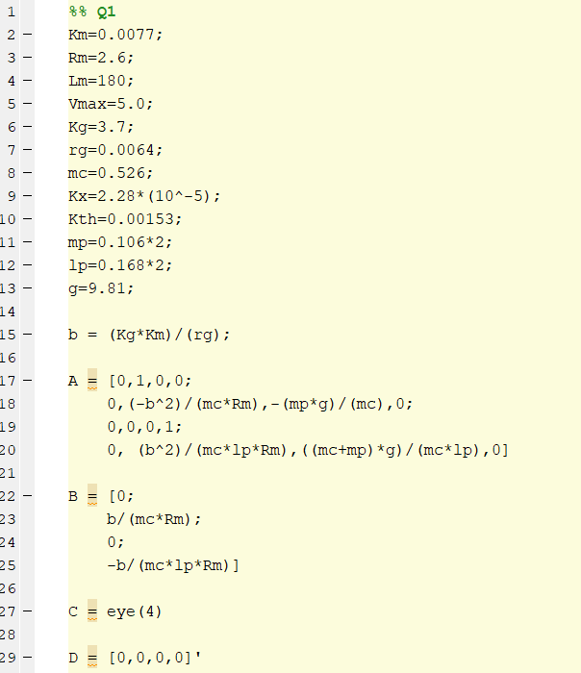

Figure1: Code to define the state space system of the cart

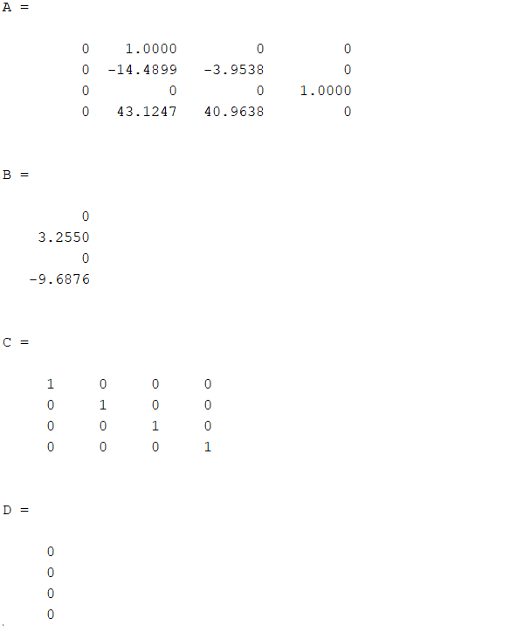

Figure 2: Matrices A, B, C and D

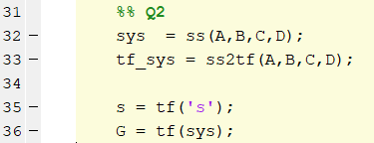

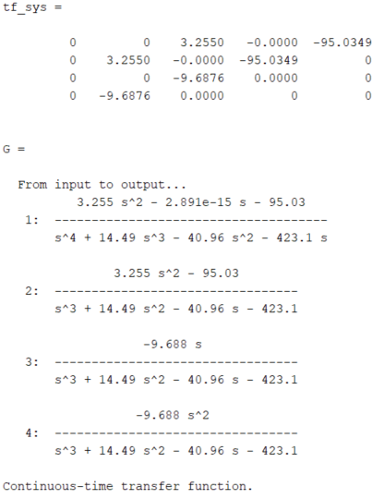

Figure 3: Definition of the transfer function on Matlab



Figure 4: pzmap function for pole placement

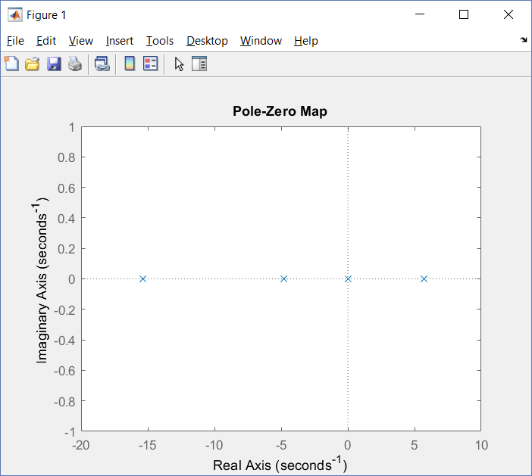

Figure 5: Pole placement



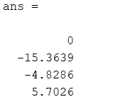

Figure 6: Eigenvalues of A

The eigenvalues of the system are equal to the poles of the system.

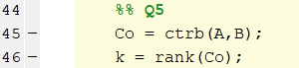

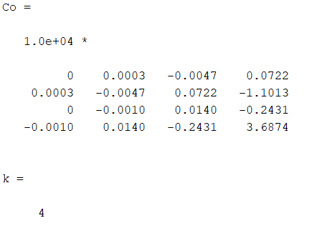

Figure 7: Controllability matrix

The system is controllable. The controllability has full rank.

We do not need to check for Observability because matrix C is full rank

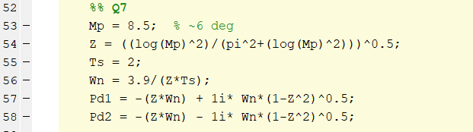

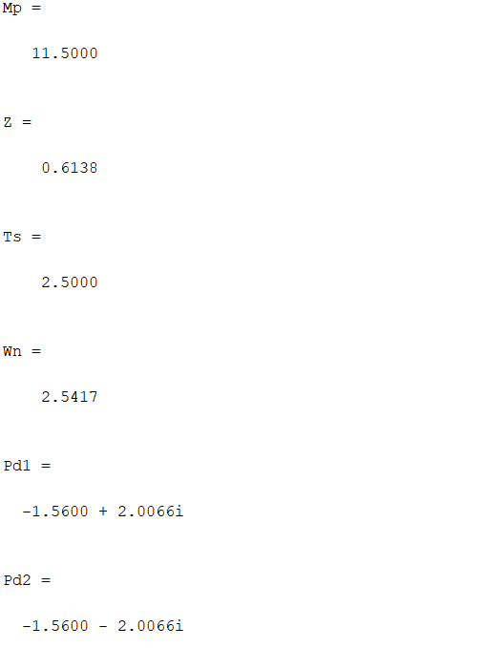





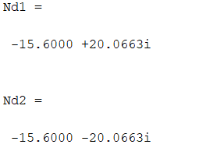



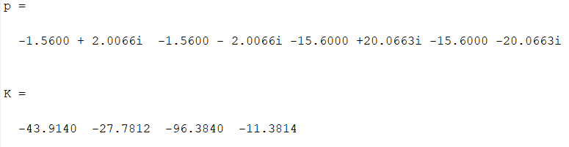

The scope of position, velocity, angle and angle velocity were identical to that of the small stick, shown in *Lab 6 Report*.

2-6)

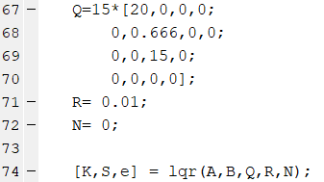

By gradually changing the values of R and Q, and with the help of the Lab Instructor we were able to narrow down on the values. We conducted tests with 20 different values.

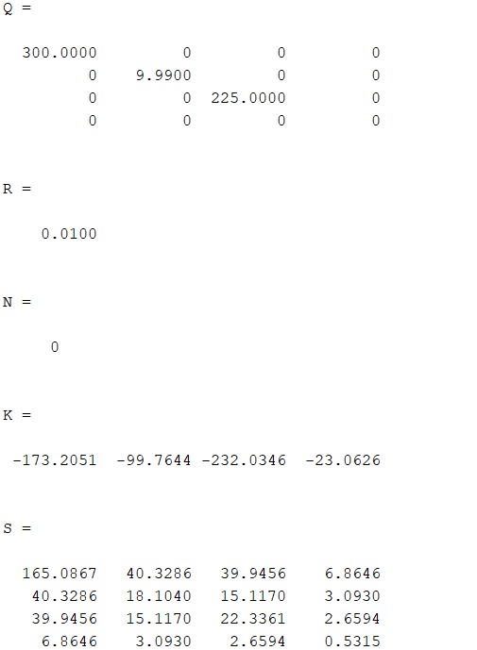

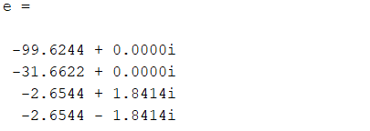

Increasing the value of K will decrease rise time and steady state error of the four quantities - position, velocity, angle, angle velocity - but increase the overshoot.

7)

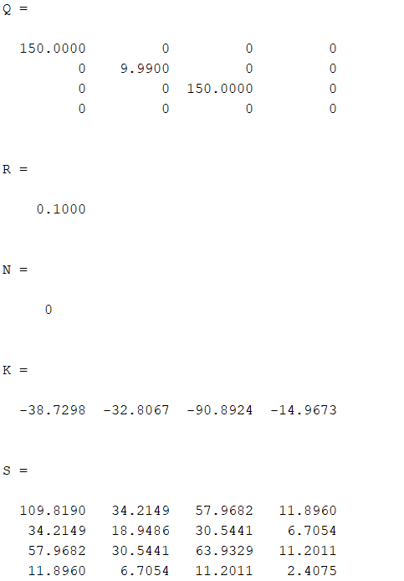

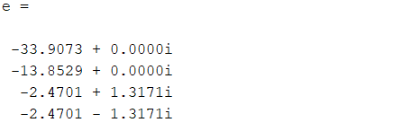

8) Matrix Q contains the costs and matrix K has the feedback gains.

System behavior after adding LQR gains, with the longer pendulum.

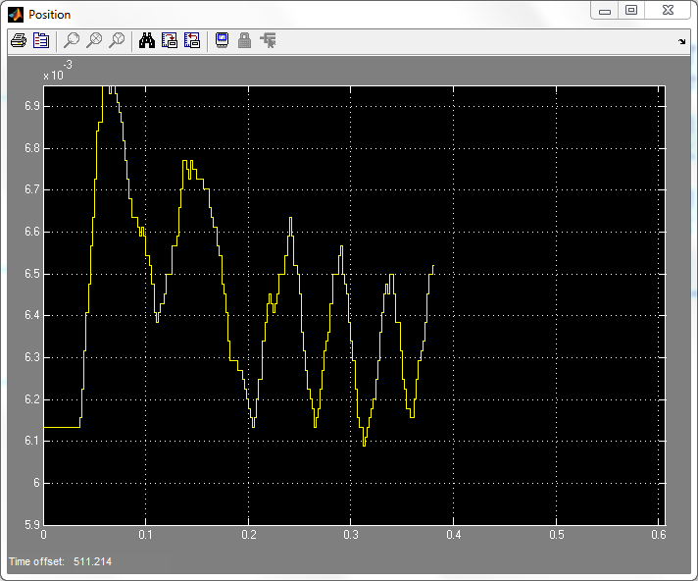

Figure: Position

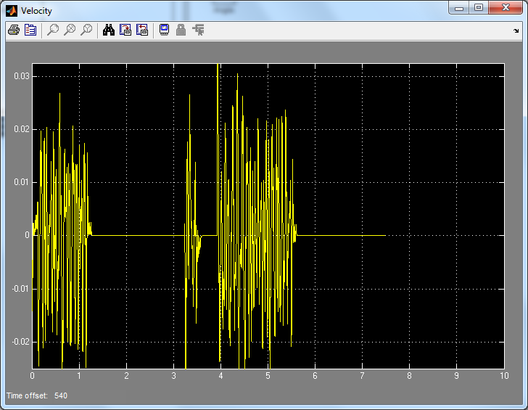

Figure: Velocity

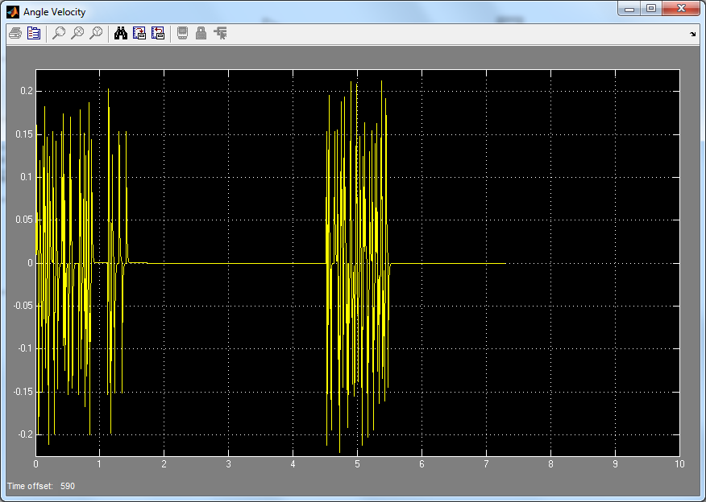

Figure: Angle

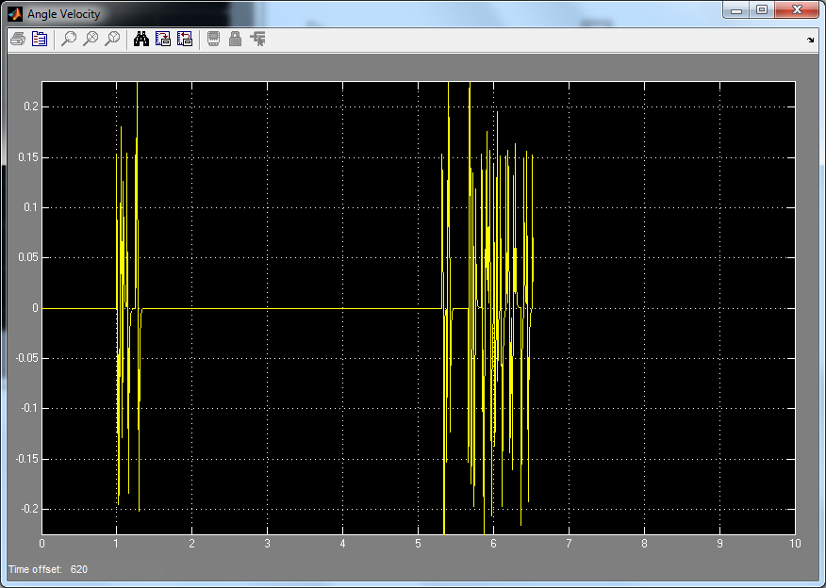

Figure: Angle Velocity

Appendix

%% Q1

Km=0.0077;

Rm=2.6;

Lm=180;

Vmax=5.0;

Kg=3.7;

rg=0.0064;

mc=0.526;

Kx=2.28*(10^-5);

Kth=0.00153;

mp=0.106*2;

lp=0.168*2;

g=9.81;

b = (Kg*Km)/(rg);

A = [0,1,0,0;

0,(-b^2)/(mc*Rm),-(mp*g)/(mc),0;

0,0,0,1;

0, (b^2)/(mc*lp*Rm),((mc+mp)*g)/(mc*lp),0];

B = [0;

b/(mc*Rm);

0;

-b/(mc*lp*Rm)];

C = eye(4);

D = [0,0,0,0]';

%%

sys = ss(A,B,C,D);

tf_sys = ss2tf(A,B,C,D);

s = tf('s');

G = tf(sys);

%%

pzmap(G);

%%

eig(A);

%% Q

Co = ctrb(A,B);

k = rank(Co);

%%

Mp = 11.5; % 11.5

Z = ((log(Mp)^2)/(pi^2+(log(Mp)^2)))^0.5;

Ts = 2.5;

Wn = 3.9/(Z*Ts);

Pd1 = -(Z*Wn) + 1i* Wn*(1-Z^2)^0.5;

Pd2 = -(Z*Wn) - 1i* Wn*(1-Z^2)^0.5;

%%

Nd1 = 10*Pd1;

Nd2 = 10*Pd2;

%% PP for Con

p = [Pd1, Pd2, Nd1, Nd2];

K = place(A,B,p);

Q=15*[10,0,0,0;

0,0.666,0,0;

0,0,10,0;

0,0,0,0];

R= 0.1;

N= 0;

[K,S,e] = lqr(A,B,Q,R,N);